## CASESTUDYREPORT

**DATA ANALYTICSWITHPOWERBI**

## “ ANALYTICSOF COMMERCIALELECTRICITYCONSUMPTION“

**SRIPARAMAKALYANICOLLEGE,ALWARKURICHI**

|  |  |
| --- | --- |
| **NMID** | **NAME** |
| **5F2A6A09354E80EB6564A6C1E130CB35** | **S.RAJALAKSHMI** |

## TrainerName:M.UmaMaheshwari

**Master Trainer :M.UmaMaheshwari**

# ANALYSISOFCOMMERCIALELECTRICITYCONSUMPTION

**Abstract:**

The demand for energy has been increasing over the years in India, which may be theresult of its rapid economic growth trajectory. In this context, this study examines thedirection of the Granger-causal relationship between electricity consumption andeconomic growth at the state and sectoral levels in India. In doing so, the panel cointegration tests with the structural break, the heterogeneous panel causality test, andthe panel VAR based impulse-response model are employed. The study covers overalleconomic growth and growth in agricultural and industrial sectors for eighteen majorIndianstates forthe period1960–61to2014–15.The results provide

## Introduction:

As an input into the production of goods and services, energy (specifically electricity)plays a major role in determining economic growth and the development of a nation(Asafu-Adjaye, 2000; Shiu and Lam, 2004; IAEA, 2009). As India is the fastest growingeconomyintheworld,itsdependenceonenergyresourceshasbeenhugeandcontinues to mount. Since 2000, India has been responsible for around 10% of the increase in the global demand for energy(MahalikandMallick,2014). Between2000and 2013, India&#39;s share in the global energy demand almost doubled. In the comingdecade, India is expected to become the primary source of energy demand growth in Asia,overtakingChina(IEA, 2015).

## EnergyscenarioinIndia:

Our country India is also one of developing country in the world among others and hereseveral kinds of sectors are performing well for nation’s achievements. India’s futuredepends on existing energy inclusion of wealth of human resources. At the same,amountofavailingEnergy andconsumptionoverit, isagreat challengeforIndian

economy to do further economic activities. Non-renewable sources plays vital amongruralIndiaforvariouspurposeincludingcookingduetovariousinconveniencesituationofalternativeenergy.Ascommercialsources,Oilismajordemandableenergyfor all sectors. But it was appeared as scarce during 1970s and it’s price also mountedup in 1975 highly but not like 1973-74 due to the disputes of imposing duties onimportinggoods.

## EnergyConsumption:

While compare the energy consumption with commercial and non-commercialenergy, people are utilizing less of non-commercial and higher of commercial energybecause of having sufficient income sources and ability for consume energy. Forcooking and heating purposes people has been using commercial fuels only such aselectricity, LPG, natural gas, coal etc. Therefore, demand for it, is always high andprovision also less of its requires because of scarce of natural energy. Already naturalor non-commercial energy is using by the people from rural not after consideringenergyfor all includinguse ascapitalforproduction.

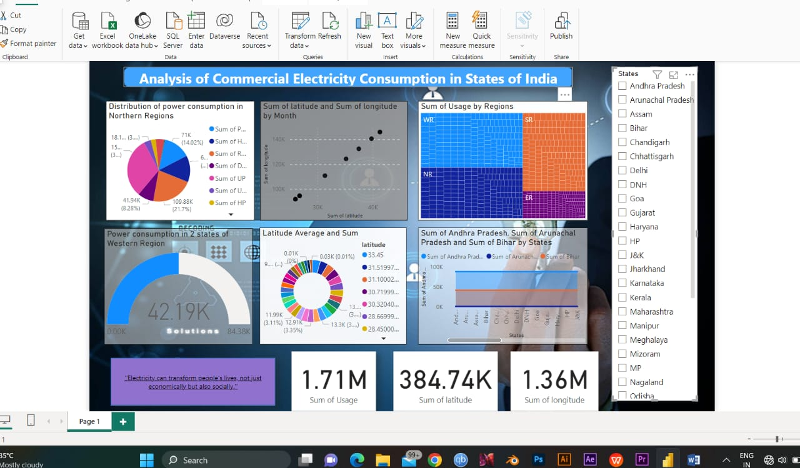

## CONCLUSION:

Based on the engraved statistical inferences pertained to commercial energyconsumptioninIndiahasbeenfluctuatingthatresultedfromfoundgrowthratetherein but 2014th result shows that begin to get develop compare to 2013thgrowth rate. While consider the total consumption of commercial energy, thathas been mounting up year by year and found at 5.48percentin compoundannual growth rate result. Consumption trends of Natural gas shows from 2008onwards.

# REFERENCE:

<https://www.researchgate.net/publication/261046177analysis>commercial electricity consumption